***Virginia Junior Classical League***

*presents this*

Certificate of Excellence

*to*

Mary Clare Young

*of*

Home School (Member-at-Large)

*for*

*1st Place in Dramatic Interpretation*

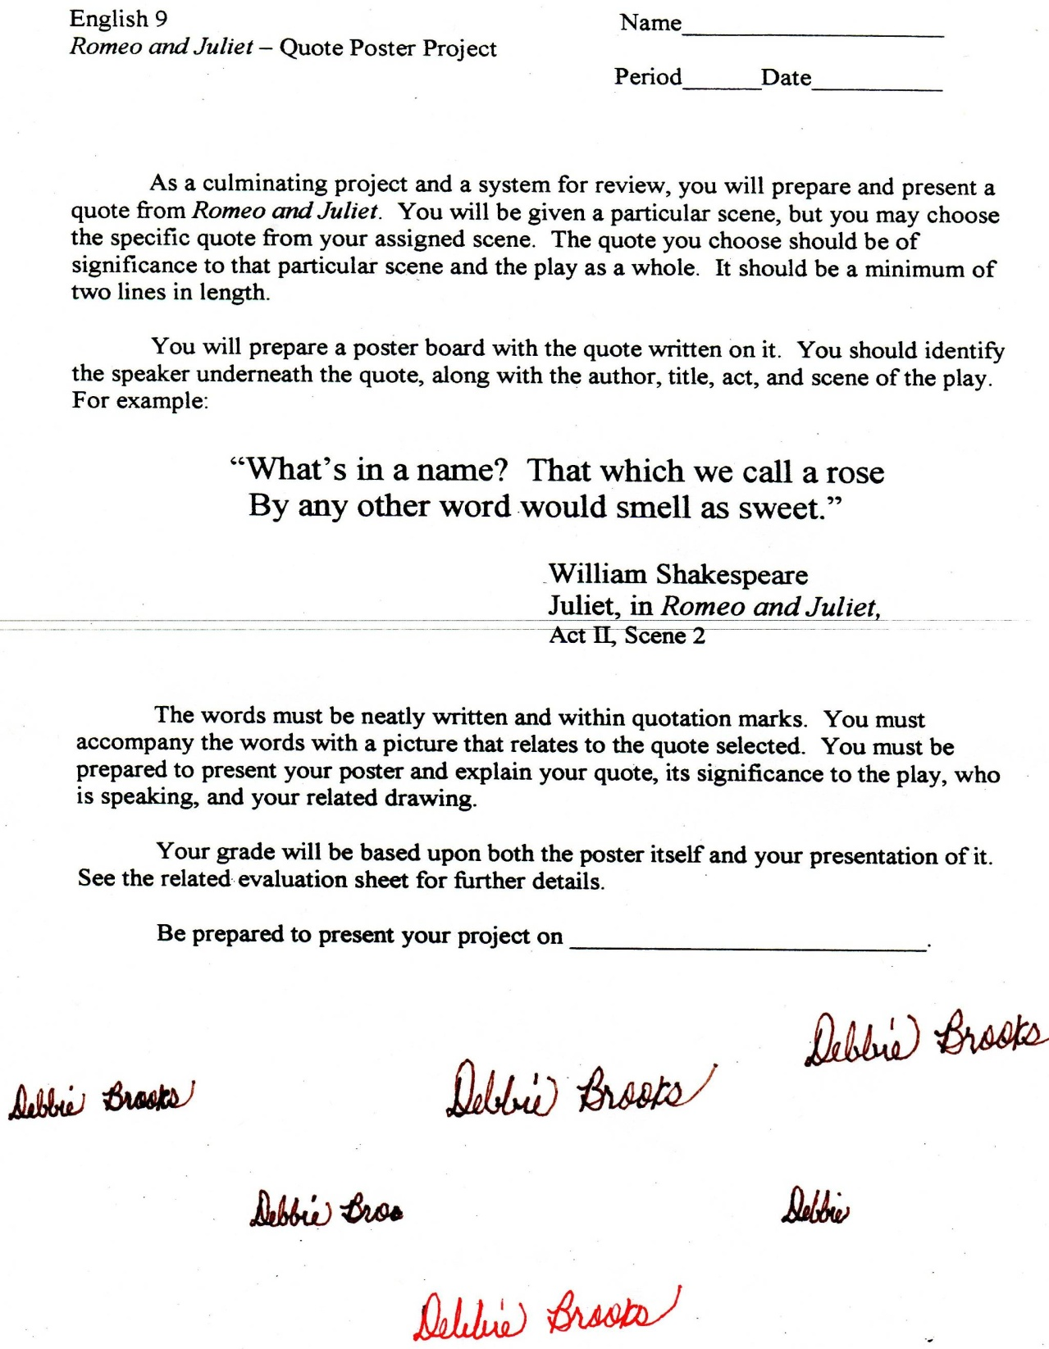

Microsoft Office Signature Line...

*a.d. viii Kal. Dec. MMDCCLXVII A.U.C. 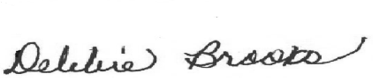*

***Virginia Junior Classical League***

*presents this*

Certificate of Excellence

*to*

Mary Clare Young

*of*

Home School (Member-at-Large)

*for*

*1st Place in Dolls*

**

Microsoft Office Signature Line...

*a.d. viii Kal. Dec. MMDCCLXVII A.U.C. *

***Virginia Junior Classical League***

*presents this*

Certificate of Excellence

*to*

Mary Clare Young

*of*

Home School (Member-at-Large)

*for*

*1st Place in Sight Latin*

**

Microsoft Office Signature Line...

*a.d. viii Kal. Dec. MMDCCLXVII A.U.C. *

***Virginia Junior Classical League***

*presents this*

Certificate of Excellence

*to*

Mary Clare Young

*of*

Home School (Member-at-Large)

*for*

*2nd Place in Derivatives*

**

Microsoft Office Signature Line...

*a.d. viii Kal. Dec. MMDCCLXVII A.U.C. *

***Virginia Junior Classical League***

*presents this*

Certificate of Excellence

*to*

Mary Clare Young

*of*

Home School (Member-at-Large)

*for*

*4th Place in Mottoes, Quotes, and Abbreviations*

**

Microsoft Office Signature Line...

*a.d. viii Kal. Dec. MMDCCLXVII A.U.C. *

***Virginia Junior Classical League***

*presents this*

Certificate of Excellence

*to*

Mary Clare Young

*of*

Home School (Member-at-Large)

*for*

*6th Place in Reading Comprehension*

**

Microsoft Office Signature Line...

*a.d. viii Kal. Dec. MMDCCLXVII A.U.C. *

***Virginia Junior Classical League***

*presents this*

Certificate of Excellence

*to*

Mary Clare Young

*of*

Home School (Member-at-Large)

*for*

*7th Place in Geography*

**

Microsoft Office Signature Line...

*a.d. viii Kal. Dec. MMDCCLXVII A.U.C. *

***Virginia Junior Classical League***

*presents this*

Certificate of Excellence

*to*

Mary Clare Young

*of*

Home School (Member-at-Large)

*for*

*7th Place in Pentathlon*

**

Microsoft Office Signature Line...

*a.d. viii Kal. Dec. MMDCCLXVII A.U.C. *